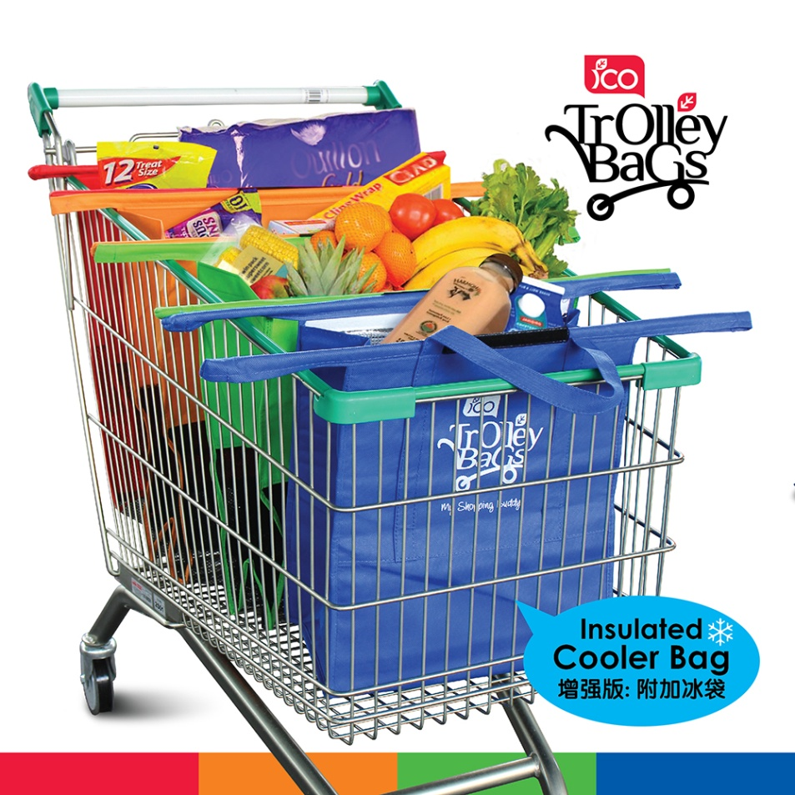

e-commerce @ shopping cart

**2019**

Nagendra

SynergisticIT

1/16/2019

**Introduction:-**

E-commerce -- electronic commerce or EC -- is the buying and selling of goods and services, or the transmitting of funds or data, over an electronic network, primarily the internet. These business transactions occur either as business-to-business, business-to-consumer, consumer-to-consumer or consumer-to-business.

**Types of e-commerce**

**Business-to-business (B2B)** e-commerce refers to the electronic exchange of products, services or information between businesses rather than between businesses and consumers. Examples include online directories and product and supply exchange websites that allow businesses to search for products, services and information and to initiate transactions through e-procurement interfaces.

In 2017, Forrester Research predicted that the [B2B](https://searchcio.techtarget.com/definition/B2B) e-commerce market will top $1.1 trillion in the U.S. by 2021, accounting for 13% of all B2B sales in the nation.

**Business-to-consumer (B2C**) is the retail part of e-commerce on the internet. It is when businesses sell products, services or information directly to consumers. The term was popular during the [dot-com boom](https://searchcio.techtarget.com/definition/dot-com-bubble) of the late 1990s, when online retailers and sellers of goods were a novelty.

Today, there are innumerable virtual stores and malls on the internet selling all types of consumer goods. The most recognized example of these sites is Amazon, which dominates the [B2C](https://searchcio.techtarget.com/definition/B2C) market.

**Consumer-to-consumer (C2C)** is a type of e-commerce in which consumers trade products, services and information with each other online. These transactions are generally conducted through a third party that provides an online platform on which the transactions are carried out.

**Online auctions and classified** advertisements are two examples of C2C platforms, with eBay and Craigslist being two of the most popular of these platforms. Because eBay is a business, this form of e-commerce could also be called C2B2C -- consumer-to-business-to-consumer.

**Consumer-to-business (C2B)**is a type of e-commerce in which consumers make their products and services available online for companies to bid on and purchase. This is the opposite of the traditional commerce model of B2C.

A popular example of a C2C platform is a market that sells royalty-free photographs, images, media and design elements, such as iStock. Another example would be a job board.

**Business-to-administration (B2A)**refers to transactions conducted online between companies and public administration or government bodies. Many branches of government are dependent on e-services or products in one way or another, especially when it comes to legal documents, registers, social security, fiscals and employment. Businesses can supply these electronically. B2A services have grown considerably in recent years as investments have been made in e-government capabilities.

**Consumer-to-administration (C2A)** refers to transactions conducted online between individual consumers and public administration or government bodies. The government rarely buys products or services from citizens, but individuals frequently use electronic means in the following areas:

* Education -- disseminating information, distance learning/online lectures, etc.
* Social Security -- distributing information, making payments, etc.
* Taxes -- filing tax returns, making payments, etc.
* Health -- making appointments, providing information about illnesses, making health services payments, etc.

### Mobile e-commerce (m-commerce)

M-commerce is a type of e-commerce on the rise that features online sales transactions made via mobile devices, such as smartphones and tablets. M-commerce includes mobile shopping, mobile banking and mobile payments.

Internet Retailer reported that mobile accounted for 30% of all the U.S. e-commerce activities in 2015. In addition, 62% of smartphone users made a purchase online using their mobile device in the last six months of 2017, according to OuterBox.

Mobile [**chatbots**](https://searchcrm.techtarget.com/definition/chatbot) also provide e-commerce opportunities to businesses, allowing consumers to complete transactions with companies via voice or text conversations.

**Modules in projects:-**

* Landing Page
* Customer
* Vendor
* Admin
* Super admin

**Website Pages@ Landing Page**

* Home
* Our Profile
* User Registration
* User Login
* Search Product
* View Details about Product
* Maintain Cart & Payment Option
* Maintain Wish List
* Send Query
* Contact Us
* Blog
* Shopping cart
* Recent Reviews
* [Order Tracking](http://localhost:4200/track-orders.html)
* About Us
* Contact Us

1. **HOME**

**Landing Page Functionalities:-**This landing page is the first page of the shopping cart application below is the different components.



**Slider Component:-**

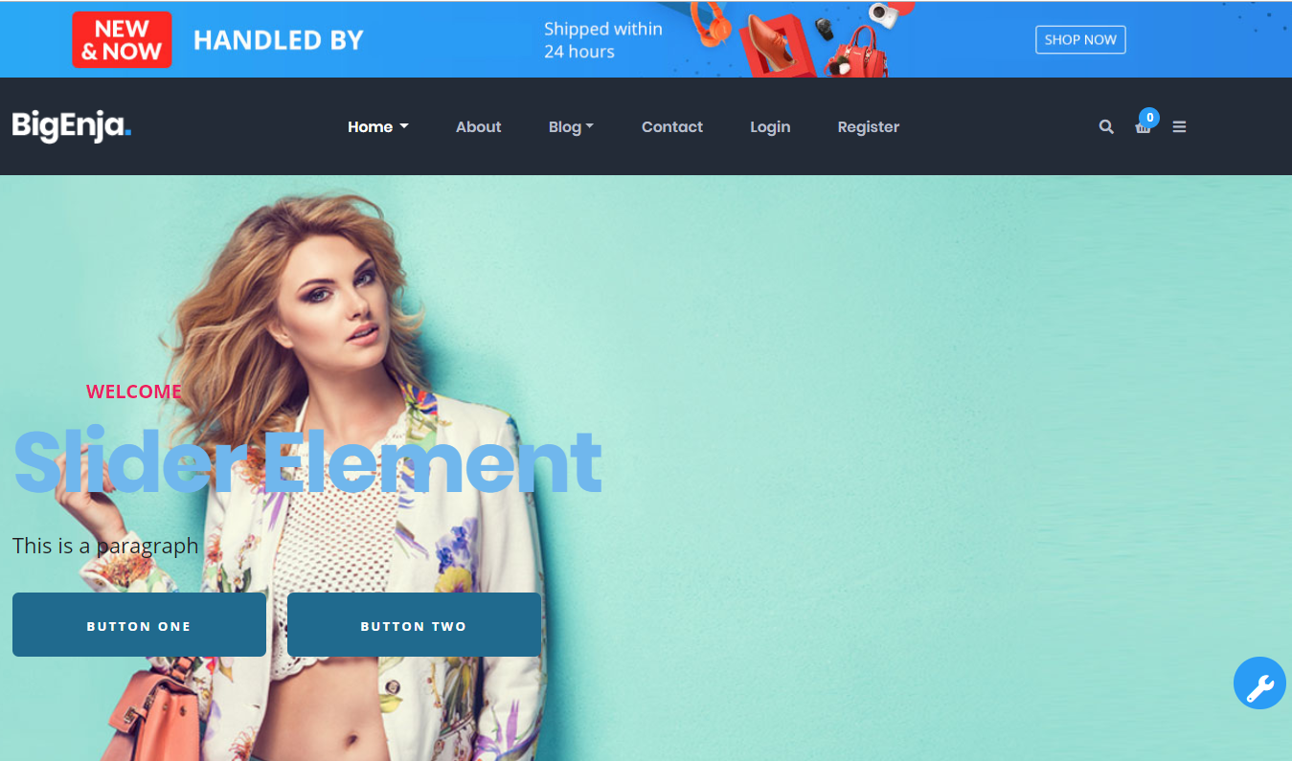

**Product Component:**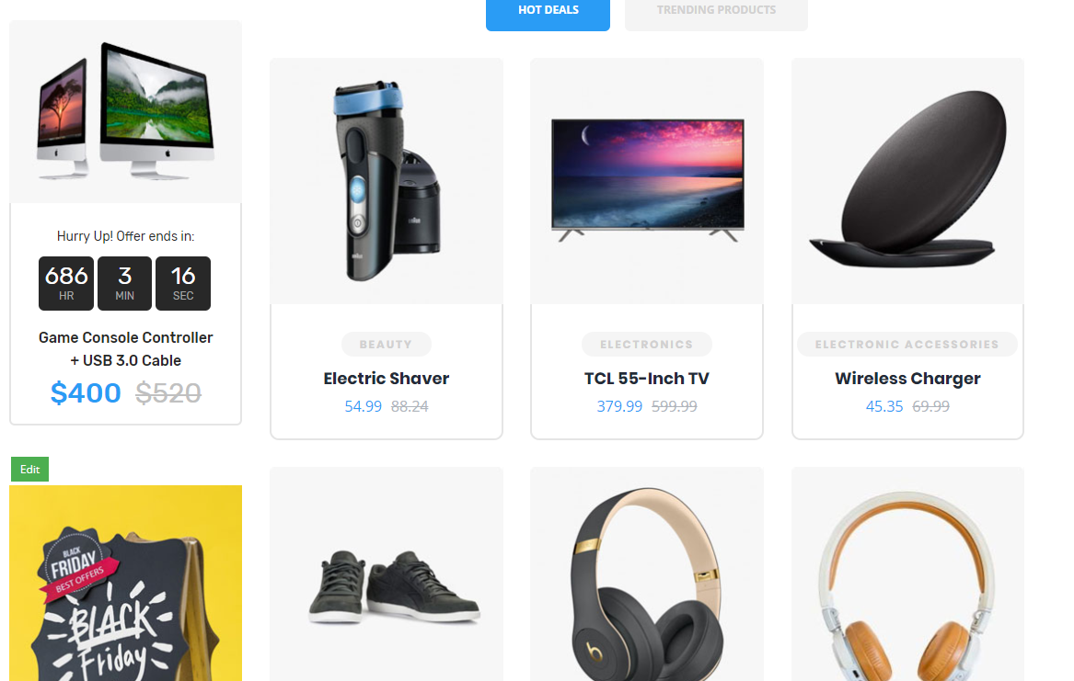

**Special Advertisement Component:**



**Ladies Cloth Advertisement Component:**

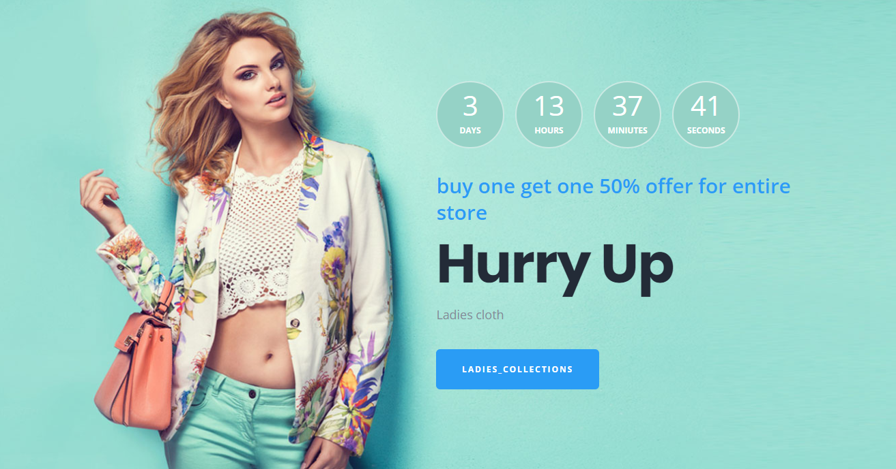

**Featured, Best Seller & Best Offer Component:**

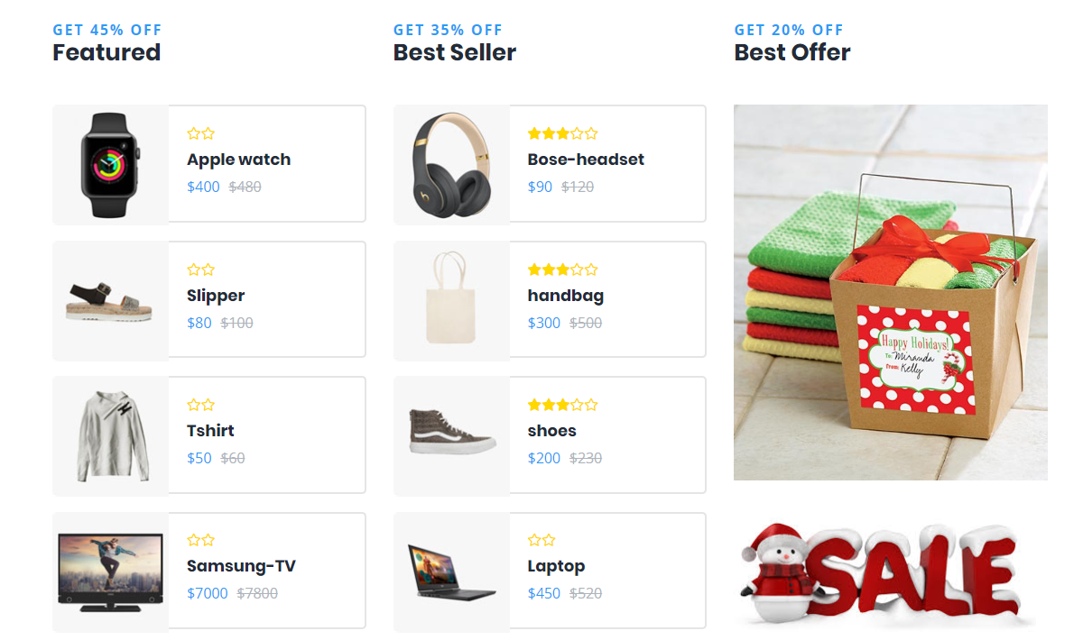

**Shopping Cart Component**

**1] Cart in top right corner**:

a) Clicking on a product should add it to the cart which appears after clicking the card icon in the upper right corner.

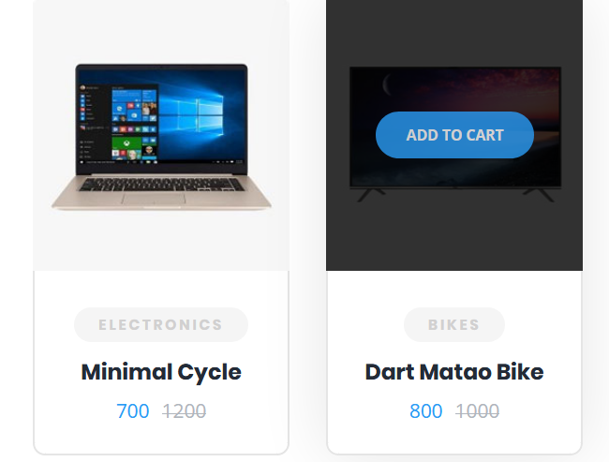

b) The number near the cart icon should increase or decrease to represent how many items are in the cart.



c) Cart area in top right should contain information such as title, price, image of product.

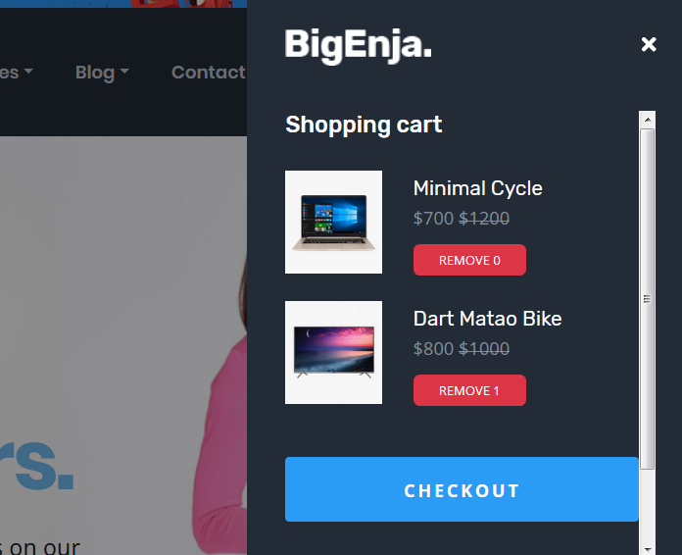

d) Clicking 'Remove' button should remove the item from the cart

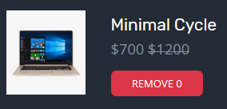

e) Cart should be persisted so that going to different pages will retain the items in the cart.

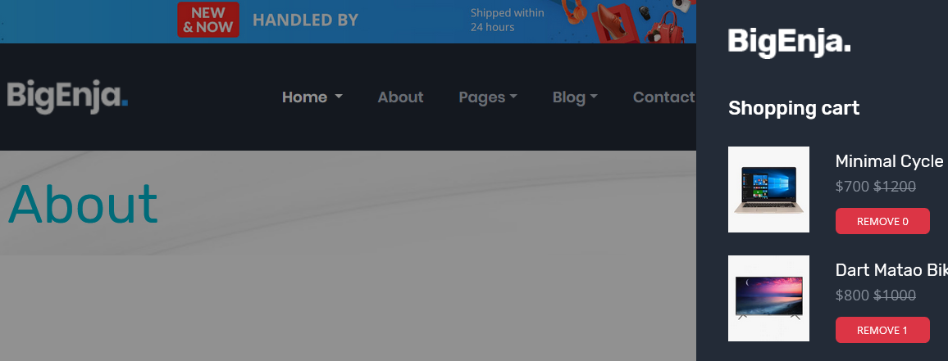

**2] Shopping cart page**:

http://localhost:4200/shopping-cart

a) Page should list products which were added into the cart.

b) Information should include image of product, product title, product price.

c) There should be a quantity area for each product which can be increased or decreased to represent the number of each product to purchase.

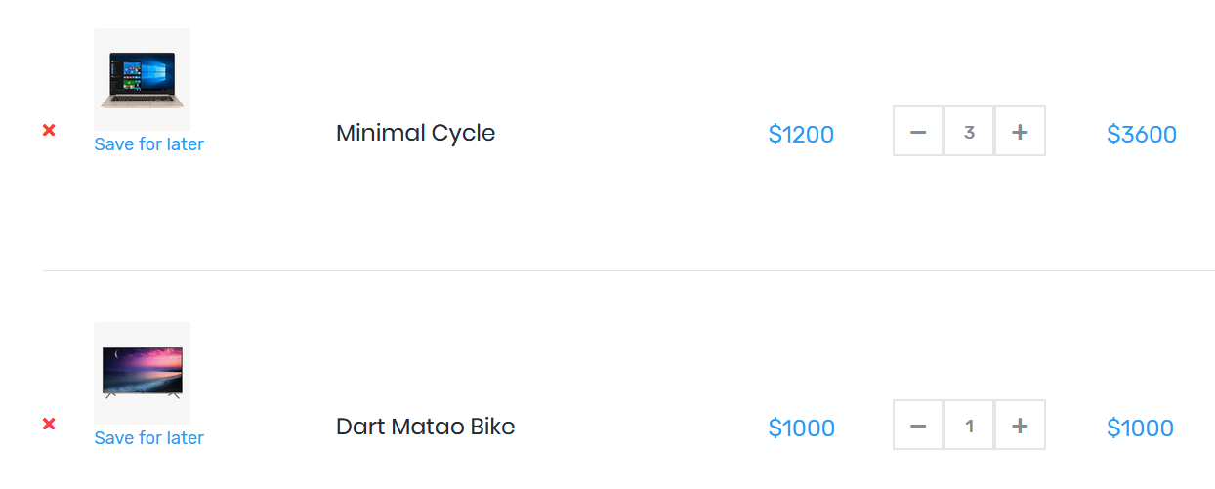

d) Price Total should increase whenever quantity is increased and decrease whenever the quantity is decreased.

**3] Save For Later:**

a) Should have a link per product to save that product for later, in case the customer does not want to buy immediately, but still keep its information.

b) Save for later products should be listed in the area below the listing of products in cart

c) Save for later should be stored in the database so those products saved can be displayed when the customer comes back later

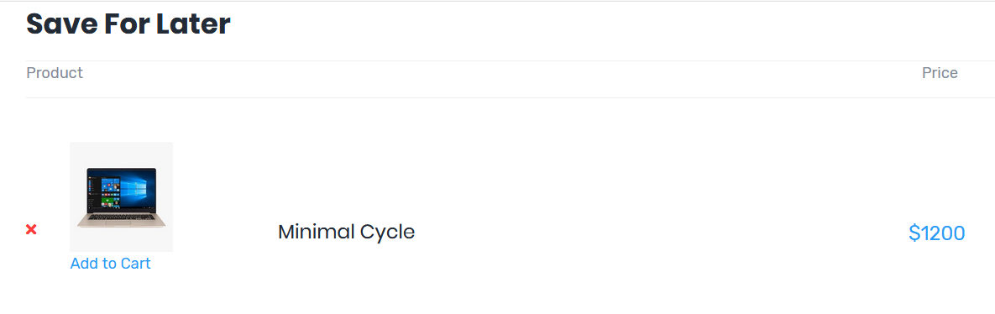

d) Should have a link to add a Saved for later product back into the cart

e) Should have a way to delete a Saved for later product

**4] Checkout:**

<http://localhost:4200/checkout>

a) Clicking checkout should go to the checkout page

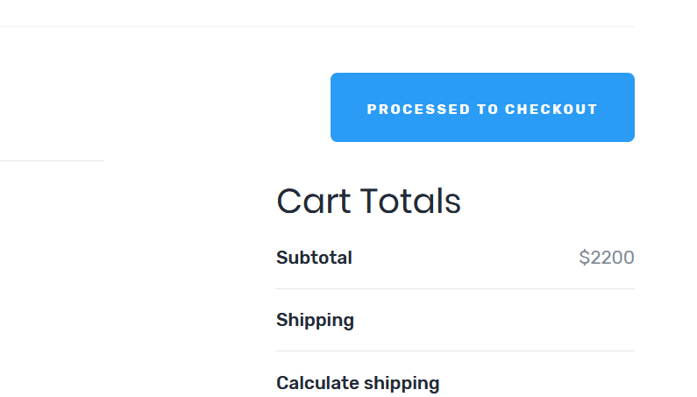

b) Checkout page should have all the products listed in the previous page with their quantity

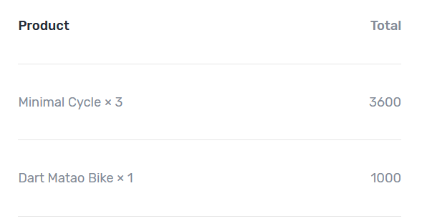

**Code Overview**

**Customer Login Area**

* Home
* Show Profile
* Update Profile
* Update Password
* Show Notification
* Show Order History
* Show All Order Status
* Order Cancel
* Wish List
* Send Query
* Today’s Deal

**Admin Login Area**

* Home
* Search / Show Customers
* Block & Unblock customers
* Manage Vendor List
* Create Product Master
* Update / Delete Product
* Manage Product Category
* Stock Maintain
* Show & Forward Order
* Manage All Queries
* Send Notification (for send any message / offer to all Customer)
* Manage Slider for Landing Page
* Manage & Design Advertisement for Landing Page
* Manage Special Advertisement Area for Landing Page
* Manage Offers
* Manage Blog List
* Manage FAQ

**Vendor Login Area(**Seller Dashboard)

* Home
* Show Profile
* Update Profile
* Update Password
* Show Notification
* Show Orders History Status placed by customers
* Manage all products
* Stock Maintain
* Total Orders
* Total Views for products
* Current balance
* Total Earning
* Sales Analytics
* Listing of top selling products
* Most Viewed products
* Latest Orders
* Latest Shipment
* Latest Invoices

Exporting and Importing the mongodb schema

C:/ >mongodump -d shopping_cart_db -o shopping_cart_db.json

2018-12-11T13:27:08.016-0800    writing shopping_cart_db.vendor_colletions to

2018-12-11T13:27:08.018-0800    writing shopping_cart_db.products_colletions to

mongodump -d <database_name> -o <directory_backup>

And to "restore/import" that, i used (from directory_backup/dump/):

mongorestore -d <database_name> <directory_backup>

With this solution, you don't need to each all collections and export one by one. Just specify the database. I would recommend against using mongodump/mongorestore for **big data storages**. It is very slow and once you get past 10/20GB of data it can take hours to restore.